**“Postman” task**

1. Download and install Postman (<https://www.postman.com/downloads/>).

2. To perform this task use the following Restful booker:

<http://restful-booker.herokuapp.com/apidoc/index.html>

3. Create a new collection for requests using four main HTTP methods: GET, POST, PUT, DELETE.

**Send the exported collection in .json format OR a .docx file with all screenshots of your requests.**

3.1. **Create a new auth token to use for access to the PUT and DELETE /booking:**

Click “Import” button -> “Raw text” tab -> Insert the required data from the “Example1” -> click “Continue” -> Click “Import”

Then check the HTTP method, Body and click “Send” button

Use received token for authorization:

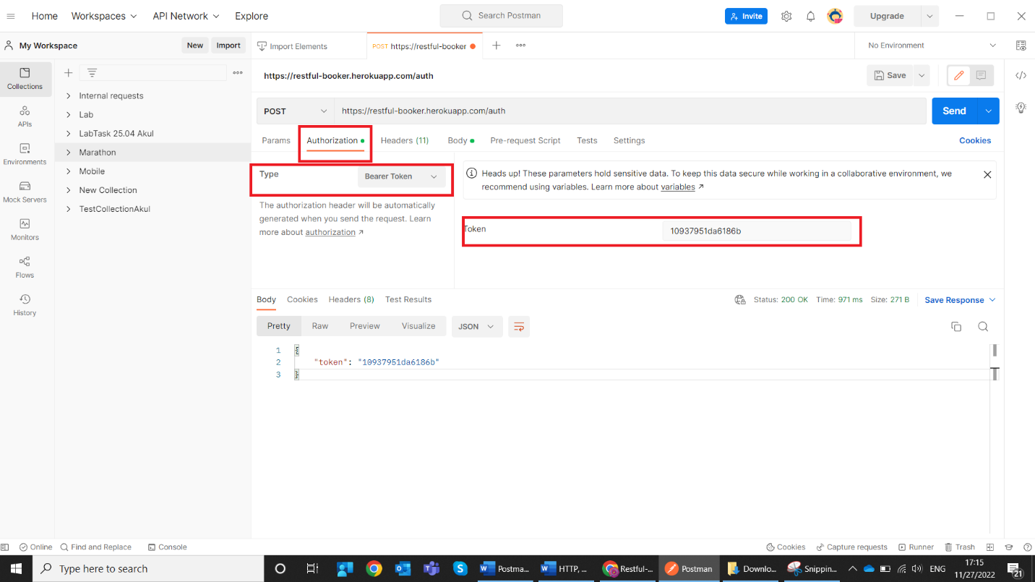

**3.2.** **Get information about a specific booking based upon the booking id provided (use GET request)**

Booking ID = 113 (should be inserted into Params -> Path Variables (KEY – id, VALUE – 113).

Use this part of API Documentation: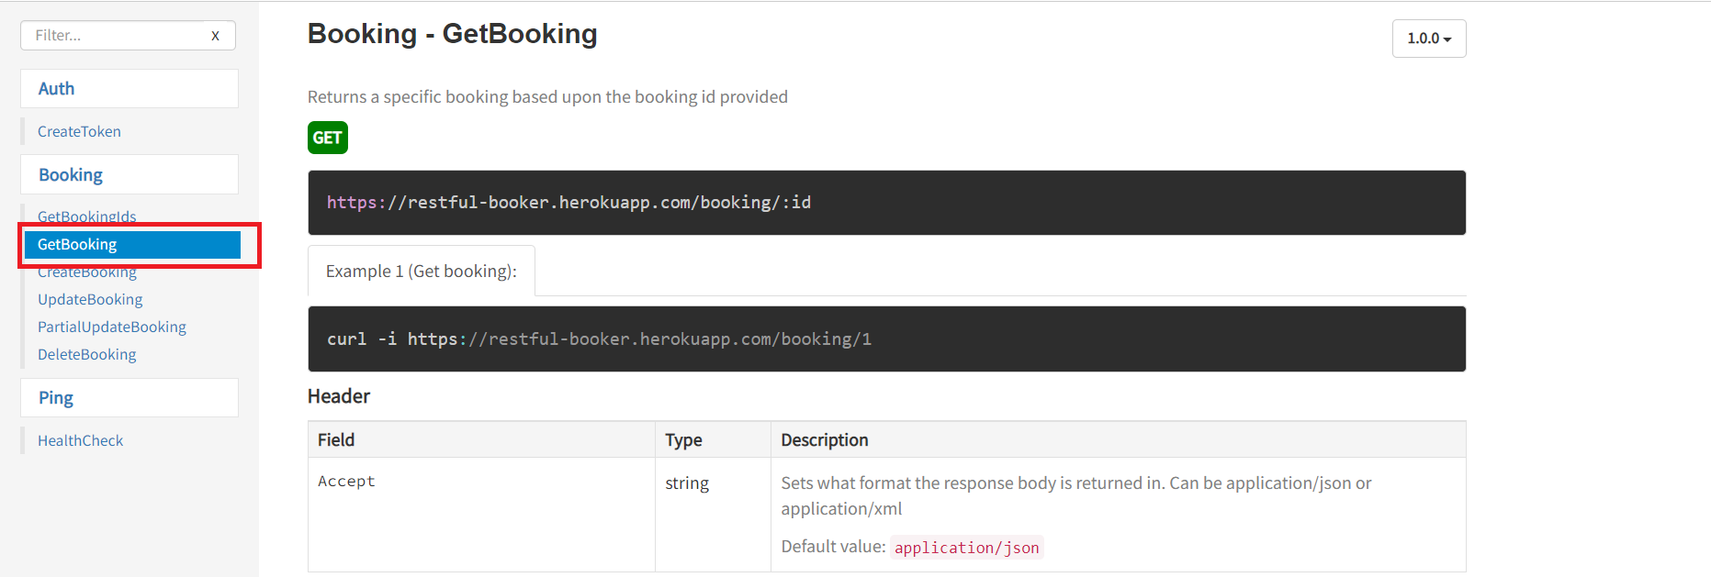

Correct JSON response for Booking ID = 113:

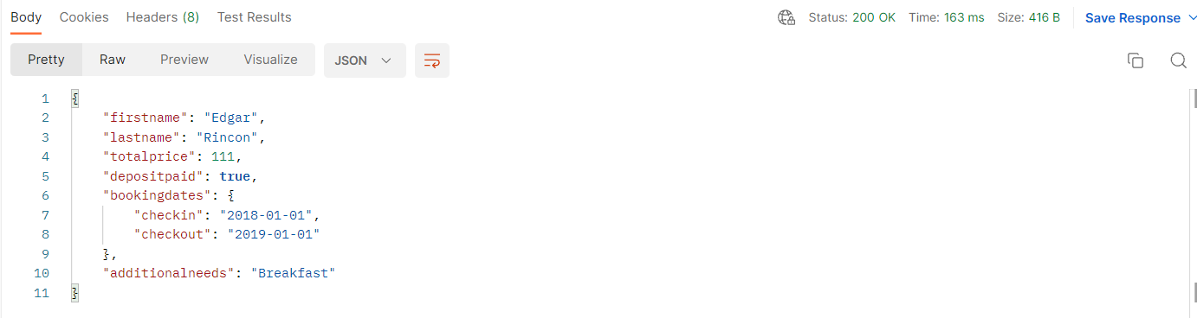

**3.3. Creates a new booking (use POST request)**

Create a new booking using any fake data. Use this part of API Documentation:

**Example:**

For the following Body:

{

    "firstname" : "Liudmila",

    "lastname" : "Akulovich",

    "totalprice" : 250,

    "depositpaid" : **true**,

    "bookingdates" : {

        "checkin" : "2023-01-01",

        "checkout" : "2023-05-01"

    },

    "additionalneeds" : "Breakfast"

}

The correct respond will be:

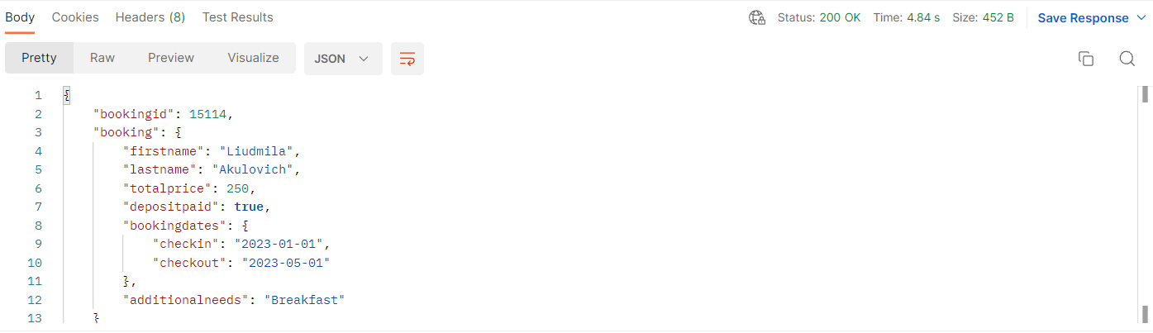

**3.3. Update the created booking (use PUT request)**

Update created booking using any fake data. Use this part of API Documentation:

**NOTE!** If you get 403 HTTP status code, make sure you’ve checked Headers.

**Example:**

For the following Body:

{

    "firstname" : "Liudmila",

    "lastname" : "Barshcheuskaya",

    "totalprice" : 115,

    "depositpaid" : **true**,

    "bookingdates" : {

        "checkin" : "2023-02-02",

        "checkout" : "2023-05-02"

    },

    "additionalneeds" : **null**

}

The correct respond will be:

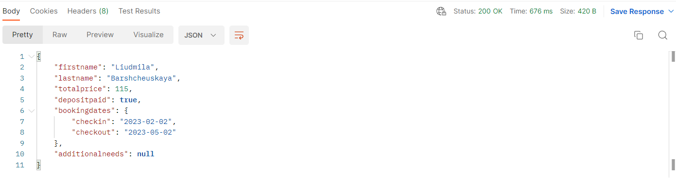

**3.4.** **Update the created booking partially (use PATCH request)**

Use this part of API Documentation:

**Example:**

For the following Body:

{

    "firstname" : "Liudmila",

    "lastname" : "Akulovich",

    "totalprice" : 312

}

The correct respond will be:

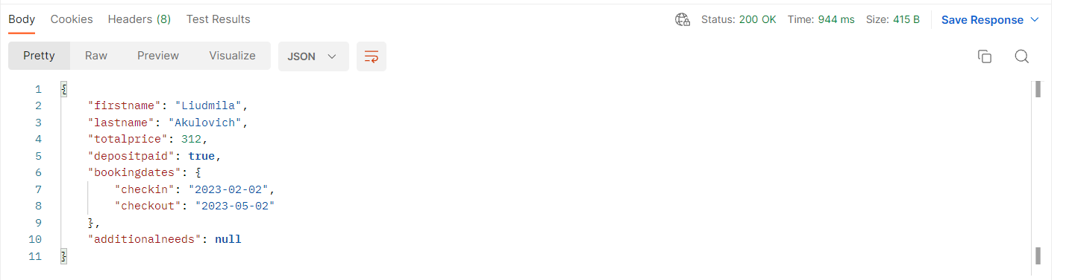

**3.5.** **Delete the created booking (use DELETE request)**

Use this part of API Documentation:

The correct respond will be:

Recheck by sending GET request:

